WEB701 Assessment 1

## Web Technologies Development Project

## Alex Herbert

## 15/07/2025

### 

### Project Brief

###### Charity: Kobra Kai

The Kobra Kai charity is a Food Bank style charity in the Nelson region who offer their free, home cooked meals delivered to people in need in the local community.

We need a website for the Nelson region for members of the charity to provide the free cooked meal delivery.

The purpose of the new website is to help with the distribution of the service or product by members of our charity to customers. Like a “food bank”, the website lets members register and describes the service or products they are providing, the number and frequency of the offerings.

The website lets members of the community (beneficiaries) access the service, by providing tokens that can be “spent” in the service. To achieve our goal, we would like to have an online token function on our website that let a beneficiary access a limited number of tokens, for example the system needs a mechanism that verifies that a member of the community is accessing the service and that the token belongs to a particular community member. The website needs some homepage text about general information of our products and services such as types, characteristics, quality factor, usage and benefit.

We require the following features on the website:

1. Charity members and beneficiaries can register, log in and administer their own accounts.
2. Members use the website to register their products and services, and beneficiaries use the system to acquire tokens.
3. Interactive element(s) that engages the website user.
4. The system provides an interface that the members can use to accept a token in a transaction.

## Short- and Long-term Goals

The following is a list of short and long-term goals that are the focus of the Kobra Kai charity website development project. These goals are intended to guide and direct the decision-making process when designing and implementing the features and functionality of the Kobra Kai website, resulting in a usable, scalable, and well performing platform that can be used by both the charity employees and the beneficiaries.

###### Short-Term Goals

* Launch a fully functional website platform that allows charity members to create an account, and list free home-cooked meals available for beneficiaries to receive.
* Enable beneficiaries in the Nelson region to create accounts, browse available meals, and request/purchase meals using digital tokens or vouchers.
* Allow delivery of cooked meals to beneficiaries from charity members, delivery days are scheduled by the charity members via the charity members dashboard.
* Facilitate efficient communication and transactions between the charity members and the beneficiaries.
* Promote the charity to the Nelson Region, helping to build exposure and audience awareness.

###### Long-Term Goals

* Platform expansion to support additional services such as donations, grocery packs, hygiene products etc.
* Integrate mobile friendly experience or a stand-alone mobile application for easier access.
* Implement automated reporting tools to track meal distribution, business analytics, and beneficiary satisfaction.
* Scale the system for use in other regions as the charity gains popularity and new branches of the charity open in other regions around the country.

## Intended Audience

Due to Kobra Kai being a charity that provides meals to beneficiaries in the Nelson region, the websites audience will vary between contributors and recipients. The following is a list of the potential target audience.

###### Primary Audience

* Beneficiaries from the Nelson region who require access to free, home-cooked meals due to hardship and personal circumstances.
* Charity Members and volunteers of Kobra Kai who donate time, money, resources, and meals to help the community.
* Charity Administration and Staff who work for Kobra Kai and require access to inventory management, donation details, and meal requests from beneficiaries.

###### Secondary Audience

* Social Services and support workers for Work and Income assisting clients in accessing food support.
* Donors or Community partners that are interested in supporting or promoting the charity.
* Developers that are maintaining and developing the platform.

### Website Appeal and Interest

“Why will people visit the website?” is an important question to answer during the design and analysis phase of the project’s life cycle. This can help to drive design decisions and prioritise the important features and functionality that is crucial to launching the platform for use by the public. The following is a list of reasons why certain audiences will visit the Kobra Kai website.

###### Beneficiaries will visit the website to:

* Register their accounts and receive digital “tokens” or “vouchers”.
* View available meals, review dietary information, order meals, and request meal delivery.
* Manage their accounts, track token/voucher balance, and view recent orders/transactions.
* Request information or support from the Kobra Kai’s support team via the websites “About” section.

###### Charity Members will visit the website to:

* Donate produce, resources, and money to the charity using the donation section of the website.
* Manage their user profiles including personal details, business details, and donation details.
* View information about the Kobra Kai charity if they are not currently members of the charity but are interested in donating.

###### Charity Administration Staff will visit the website to:

* View and manage donation requests made by charity members and meal requests made by beneficiaries.
* Track and manage donations made such as produce, money, or time volunteering.
* Answer support requests made by beneficiaries or charity members.

## Defined Kobra Kai Audience

The Kobra Kai Charity has two distinct user/audience groups, the beneficiaries, and the charity members/staff. Defining the audience for the Kobra Kai charity website is crucial the features and functionality that is expected by the users of the platform, this will help make informed decisions during the analysis, design, and development phases of the project’s life cycle.

#### Beneficiaries

###### Demographic – Individuals or Families in the Nelson region experiencing financial hardship.

*Technical Proficiency* – Proficiency varies from low to moderate technical abilities and experience, platform interface must be simple, mobile-friendly, and accessible.

*User Needs*

* Easy registration/login process.
* Account management and order history.
* Clear display of available services and meals.
* Token tracking and balance display.
* Privacy and data security must be compliant with New Zealand privacy law to promote trust in the platform/charity.

#### Charity Members

###### Demographic – Local community volunteers, hospitality businesses, and charity partners.

*Technical Proficiency* – Moderate to High technical skills.

*User Needs*

* Ability to register, login, and manage charity member accounts.
* Interface to list meals/services provided (description, quantity, delivery schedule).
* Token redemption/order confirmation process.
* Communication and transparency with beneficiaries.

### User Scenarios

###### Scenario 1

Aroha is a single mother of two that lives in the Richmond area and has recently been made redundant from her job. She is investigating the type of assistance she can receive online and finds the Kobra Kai website during her search. After reviewing the services available on the Kobra Kai website, she registers for an account and receives 10 tokens to be used to purchase meals from the charity providers. She browses the available meals on the website and orders a Roast Beef meal from one of the charity members, the order is placed using 1 of the tokens. The website confirms her purchase, places the order with the charity member business, and the meals are delivered later that evening.

###### Scenario 2

Jackson is a father of two and husband to Jennifer, he has recently been experiencing hardship due to a lack of work available in his profession as an orchard foreman. He is looking into how he can get support from the local community for him and his family online and discovers the Kobra Kai charity website. He browses the websites available services and decides to create an account with Kobra Kai. After registering for an account using his community services number, he receives 10 tokens to be used to order meals. Jackson browses available meals from the charity members and chooses to order three of the Lamb Shank meals from one of the local restaurants, he is charged three tokens from his account balance, the order is confirmed, and the order is delivered later that afternoon.

###### Scenario 3

Mike is a retired Chef and has been living and working in the Nelson region for the past 15 years, he wants to give back to the community using the skills he has acquired during his career. He discovers the Kobra Kai website and after reviewing the services available, he registers for a Charity Member account. Once he has entered his details and the account registration is completed, Mike lists 10 roast chicken meals that he has prepared for donation. The system allows him to specify what days he is available for delivery, so he sets the delivery days to Monday, Wednesday, and Friday. When beneficiaries use their tokens to order meals from Mike, he receives a notification with the beneficiaries’ delivery address, and marks the meal as delivered once the order has been fulfilled.

###### Scenario 4

Tania, a social service worker for WINZ, helps multiple families to get set up to use the Kobra Kai services. She uses the website’s public-facing information to understand how it works, then assists families and individuals experiencing hardship to register for an account and shows them how to use the tokens they are provided. She also coordinates with the Kobra Kai charity staff and administration team by giving them feedback she receives from beneficiaries via a contact form on the website.

## Competitive Analysis

To fully understand the Kobra Kai website functionality and user experience, analysing other competing charity organizations websites will help to inform better design decisions for this project. This process will reveal design choices and functionality being used by other charity web platforms that can be utilized in the Kobra Kai website project, resulting in a more defined set of functional requirements and better user interface designs.

#### Competitor 1 – Foodbank NZ

###### Website URL - <https://www.foodbank.co.nz>

Foodbank NZ is a online directory for all the foodbanks in New Zealand, it provides users with a easy to navigate interface that can be used to discover foodbanks in each region, town, and city in New Zealand. Users can find the contact details for each foodbank, as well as find information and criteria on how to apply for food parcels. Users that wish to donate or promote specific food banks can do so via a payment portal that is available on the websites interface.

###### Features

* Serves as a directory for local Foodbanks in each region in New Zealand.
* Foodbanks searches can be selected by region and then filtered by city/town.
* Provides users with information on how to apply to receive food parcels from the selected food banks.
* Allows users to donate via debit/credit card to the foodbank services.
* Advertising sponsorships are available to donors to help promote a specific foodbank.
* Foodbank details are displayed for each town/city, allows users to contact them directly, or to visit the physical location.

###### Strengths

* Centralized directory of foodbanks across New Zealand.
* Basic, and easily navigable website interface.
* Donations are made easy via a payment portal that is linked directly to the website.
* Foodbank information is easily accessible.
* Information regarding applications for food parcels is clear, easy to find, and provides adequate details on who is eligible for support.

###### Weaknesses

* No online interaction with the Foodbanks via the website, users must contact the Foodbanks through other means.
* Limited information on the food that is provided by the foodbanks on the website.
* No token or voucher functionality is implemented allowing users to order food parcels via the website.

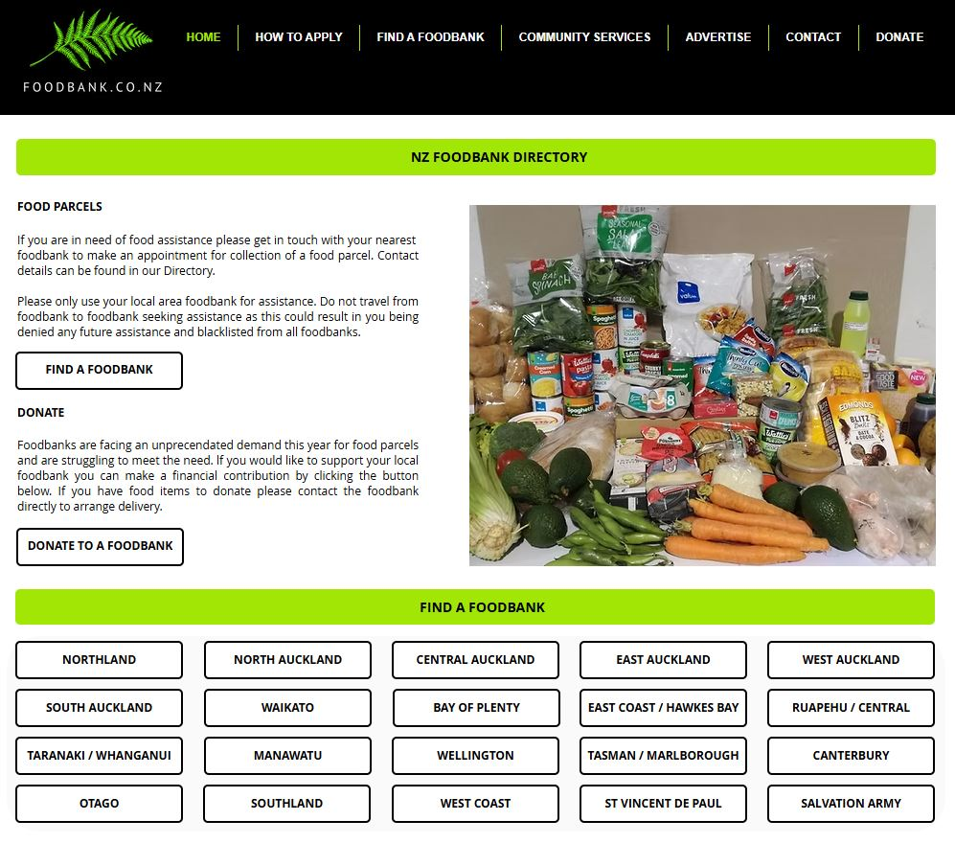

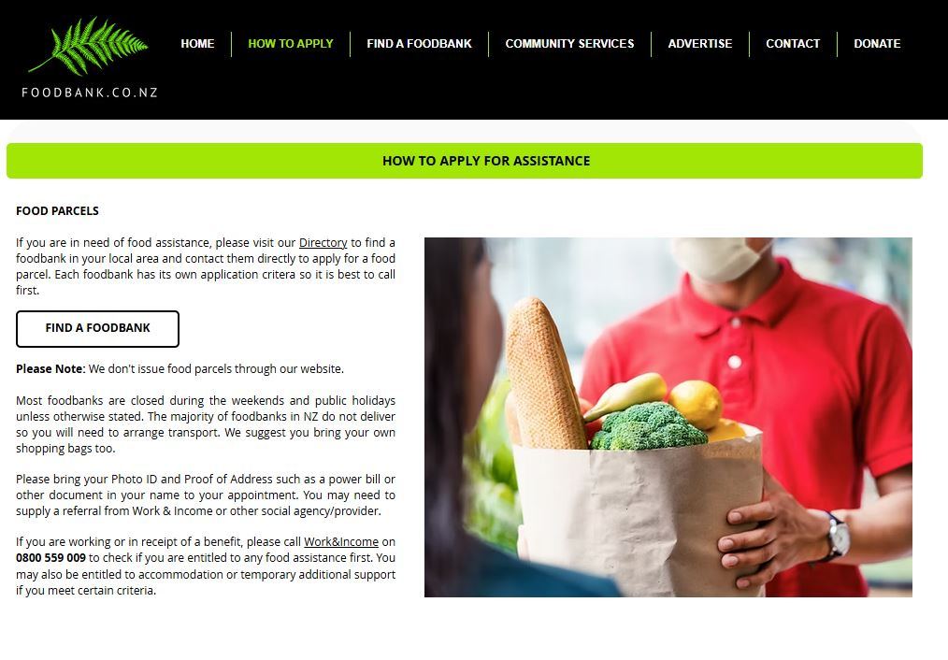

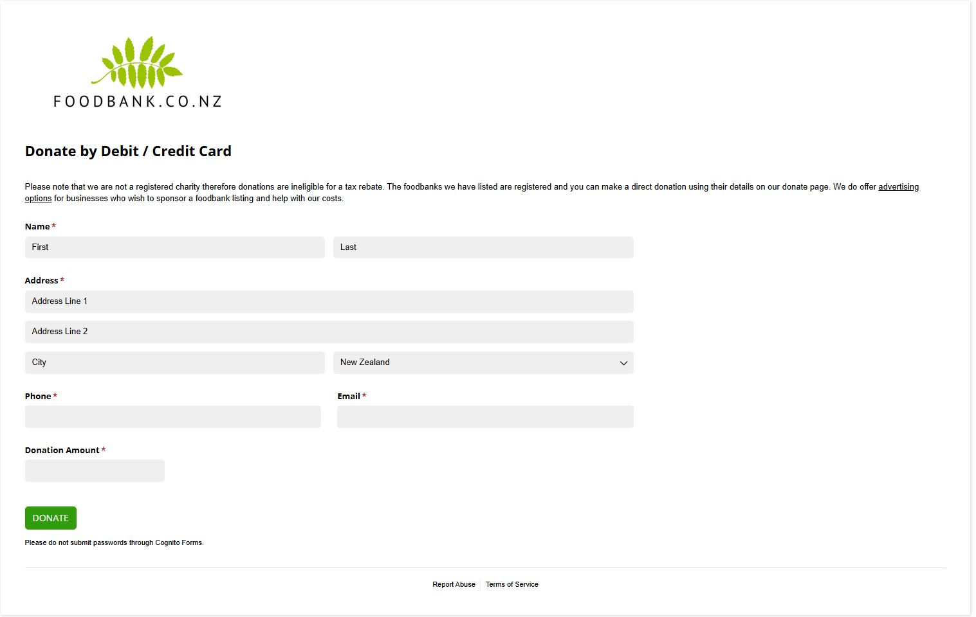

(Images taken from Foodbank NZ website. <https://www.foodbank.co.nz>)

#### Competitor 2 – Bellyful

###### Website URL - <https://bellyful.org.nz>

“*Bellyful is a volunteer-led charity nourishing whānau and connecting communities by delivering free meals to families with babies and young children who are without a support network.*” (Bellyful. 2025.)

Bellyful is a nationwide charity organization that provides families with babies, or children under the age of 12, in need of support due to financial hardship or difficult life circumstances with healthy, homecooked meals free of charge. The meals are delivered to the beneficiaries by the charity and is well supported through funding, donations, and grants given by community organisations.

###### Features

* Comprehensive information about the charity and how it operates is provided to the user on the website.
* A full list of the Bellyful branches is made available via the website’s navigation.
* Support request forms are available to the user via the website for each branch.
* Users can order/requests meals directly from the website interface, additional contact with the charity is made to confirm the requests.
* Donations are made possible via the website donations page; payments are made via Stripe without needing to be redirected from the website.
* Website is easy to understand and navigate.

###### Strengths

* User interface is engaging, easy to navigate, and contains concise information regarding the charity’s operations and goals.
* Website content includes translations in Te Reo Māori, some are bi-lingual by default, such as the navigation bar, allowing native language speakers to be included.
* Request forms and Donation forms are comprehensive, easy to understand, and provide users with multiple options about how they wish to be contacted and receive/donate support.
* Bellyful branches are easily discoverable and accessible via the website navigation.
* Call to Action buttons are bright and highly visible to the user, making navigating the website easy for all users.

###### Weaknesses

* Some of the website “About” and “Get Involved” pages are quite verbose and contain a lot of information that may not be relevant to the beneficiaries. It can be overwhelming when searching for specific information.
* Website does not contain a search functionality, allowing users to quickly find the services/branch they are looking for.
* The addition of Te Reo in the website navigation can make finding specific services or pages difficult due to additional text in navigation drop down menus. This could be improved via having the website translation optional for all the website content and not having Te Reo as a default in some website elements.

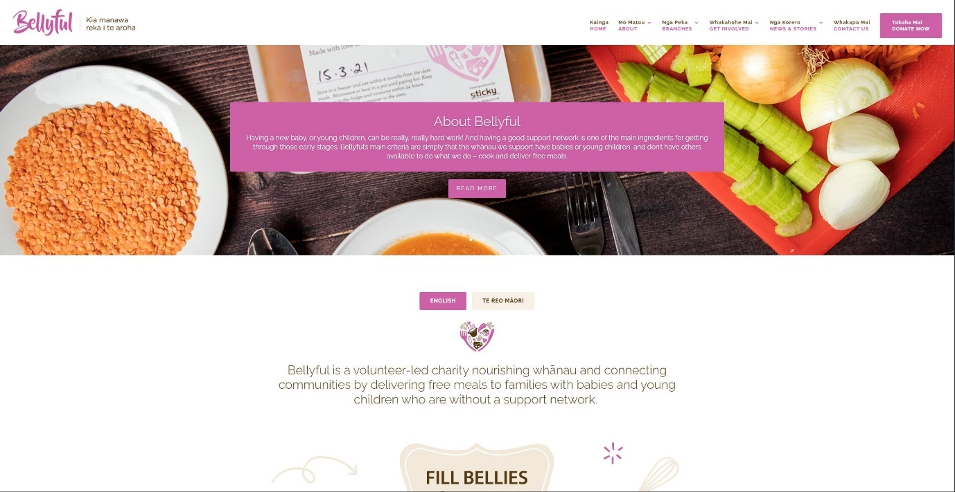

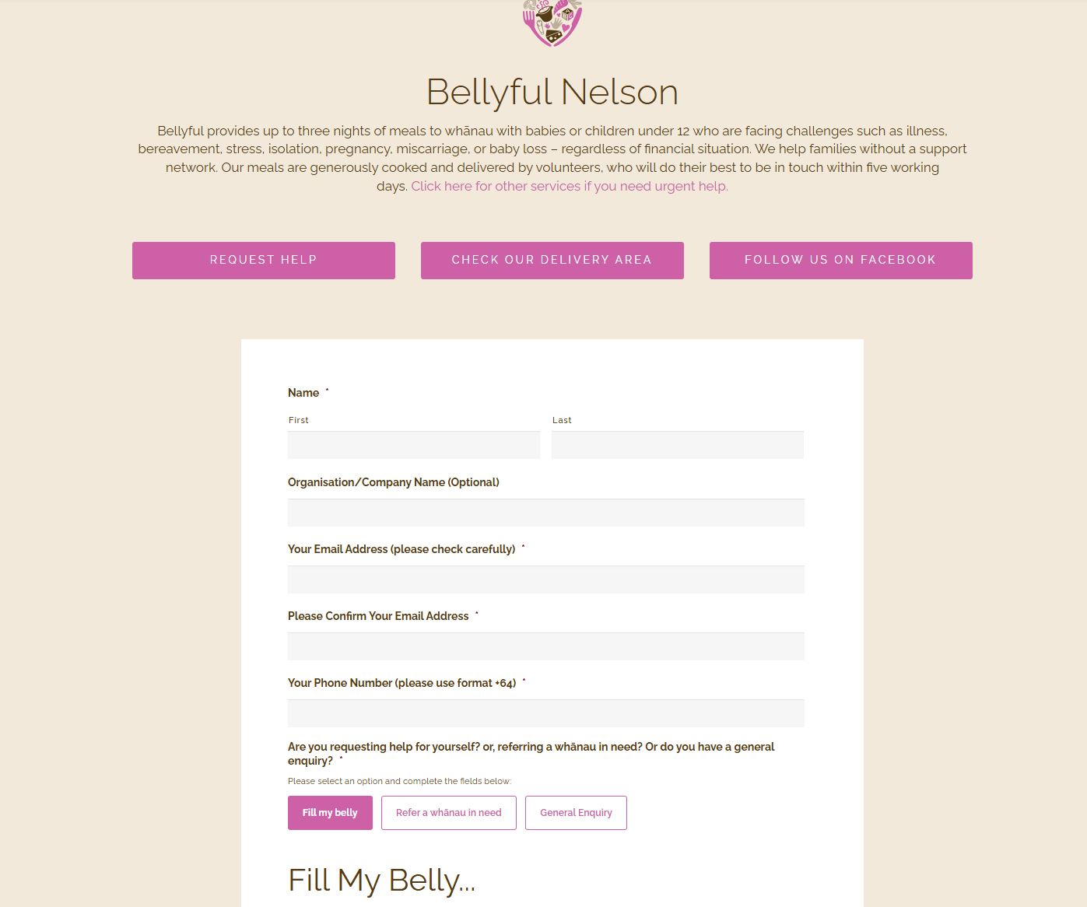

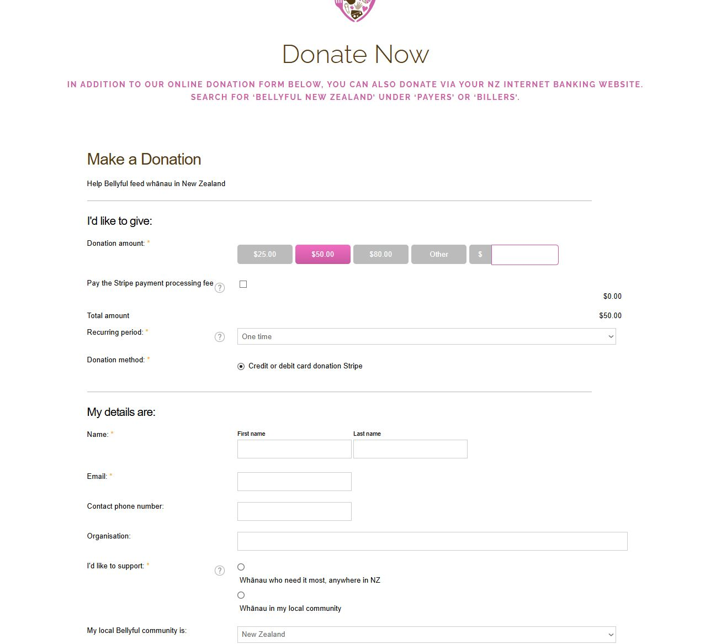

(Images taken from the Bellyful website. <https://bellyful.org.nz>)

## Website Content

The following table outlines each page of the website, and the expected content on each page, this will be used to inform design decisions, functionality, website navigation, and the content that is expected to be displayed.

|  |  |
| --- | --- |
| ***Page/Section*** | ***Content Description*** |
| Home page | Overview of the Kobra Kai charity’s purpose, mission/goals, services offered, beneficiary testimonials, how it works, and a call to action for user account registration and donation. FAQ’s are located at the bottom of the home page. |
| Meals Page | Displays charity member businesses/organizations with available meals, each member business/organization meals that are available with detailed dietary information, quantity available, delivery schedule, ordering form/functionality with token exchange. |
| About Page | Background and origin of the charity, future vision, meal delivery system information, charity member/donor details. Contains Privacy Policy, terms of service, and Legal information. |
| Contact Page | Charity details, contact form, email address, phone number, physical location charity office address. |
| User Login/Registration | Forms for entering user credentials for login, registration form for new account creation. |
| Account Management | Beneficiaries account information, token balance, order history. Charity Members account information, meal details/management, delivery orders/history. |

## Functional Requirements

The following is a list of the expected functionality and features of the Kobra Kai website platform, these will be used by the developers to design and develop the website’s functionality as well as the code implementation.

#### Functional Requirements

###### User Account Registration and Management

* Both User types (beneficiaries and charity members) must be allowed to create accounts and login to their accounts using a secure authentication interface.
* Two registration forms must be implemented, one for each type of user, containing the fields that are required by the business for both types of users.
* Beneficiary Users must be able to view and manage their account information from an Account Management Dashboard, this includes token balance, order history, and account information update/deletion features.
* Charity Members must be able to manage their account information and the “Meal” information that they have available; this includes CRUD operations for meal details, quantity, dietary information, and delivery schedule from the Account Management Dashboard.

###### Browsing, Ordering, and Managing Meal Delivery

* Beneficiary Users must be allowed to browse Charity Member Businesses, available meals, dietary information, quantity available, and order meals using tokens from the “Meals” page on the website user interface.
* Orders made by beneficiaries must display an order confirmation message.
* Beneficiary Token balance must be updated after orders have been placed.
* Charity members must have new orders added to their “Pending Orders” section of the Account Management Dashboard upon order confirmation.
* Charity Members must be given the option to fulfil the order upon delivery, adding the order to the “Completed Orders” section of the Account Management Dashboard.
* Charity Members and Beneficiaries must be given the option to cancel an order due to unavailability, mistakes, or errors.
* Beneficiary delivery information such as addresses and preferred delivery dates must be included in the Order information that is displayed to the Charity Members in the Account Management Dashboard.

###### System Level Functionality

* The system must contain and API that handles http requests and responses, this API serves the front-end user interface with the content for each page and handles the requests for Ordering and Account management/authentication functionality.
* The system backend must contain a database that stores the platforms data securely and efficiently, data retention policies must comply with New Zealand Privacy law.
* The system must use JWT (JSON Web Tokens) to encrypt/decrypt user credentials for a secure login and authentication process.
* Backend logic must contain CRUD operations and functionality that is inline with the features and functionality of the front-end user interface.
* Service/business logic must validate user inputs and requests from the front-end user interface input, and handle errors and invalid inputs gracefully, displaying error messages to the user with details and suggestions for correct input requirements.

#### Non-Functional Requirements

###### User Interface

* The User Interface must contain website navigation that is easy to use for all skill levels, be direct and descriptive, and viewable from each page on the platform.
* Website design, colour scheme, fonts, and content placement must be readable, easy to navigate, and representative of the Kobra Kai charity marketing/branding.
* Buttons and Call to Action elements of the user interface must be easily noticeable, descriptive of the actions they invoke, and clickable by the user.
* Website content must be clearly displayed, relevant to the page that is describing, and make sense to the user.
* Charity Member information must be viewable and displayed to the user clearly as part of the “Meals” page.
* Dietary information for meals must be displayed for each meal that is available for order/delivery.
* Beneficiaries Token balance must be displayed on the user interface whilst browsing for available meals.
* Confirmation messages and Error messages must be clearly displayed to the user and contain relevant information that informs the user of the completed/incomplete action.
* The interface should comply with accessibility best practices (ARIA roles, alt text) and render effectively on mobile devices.

###### System Level Requirements

* The system must be designed and implemented to accommodate scalability for future growth of the charity.
* The system must have high levels of performance, fast loading times, and handle user traffic when being used by 100-200 users simultaneously.
* The performance of the system must be optimized to allow for future growth of the charity and is expected to reach 1000 concurrent users in the future.
* The database must be able to handle multiple transactions simultaneously without hindering performance.
* Data transfer must be secure and encrypted to ensure high levels of security and to protect users’ data from potential interception and cyber-security threats.

## Site Content Groups and Labelling

To make sure that the Kobra Kai website has an intuitive and accessible user experience, the content for the website is grouped into logical categories based on the user roles and common tasks that will be performed. These groupings are labelled with clear, user-friendly navigation terms that match the expectations of the users and the Kobra Kai web platforms goals.

###### Main Navigation Structure and Labels

|  |  |  |
| --- | --- | --- |
| ***Navigation Label*** | ***Group*** | ***Description*** |
| Home | General | Introduction to the Kobra Kai charity platform, overview of the services provided, calls to action (Register/Login, Order), beneficiary testimonials. |
| Meals | Beneficiaries | Displays the available meals from each Charity member available to order, sorted by the provider and contains dietary information. |
| About | General | Charity background, founders, and origin story, mission, vision, goals, privacy policy, and legal disclaimers. |
| Contact | General | Kobra Kai contact information such as phone, email, address, and opening times. Donation and Support details are also located here. |
| Login/Register | Authentication | Login and Registration forms for both User types. Allows users to login, and/or register for an account. |
| Dashboard | Authenticated Users | Account Management Dashboard containing User details, Orders (current and pending), token balance, and meal/order management for Charity Member users. |

###### Account Management Dashboard Content Grouping

|  |  |  |
| --- | --- | --- |
| ***User Role*** | ***Dashboard Sections*** | ***Description*** |
| Beneficiary | * Token Balance * Order History * Personal Details * Delivery Details | Contains the beneficiaries account details (updateable), tracks current/completed orders, displays token balance. |
| Charity Member | * Meal Details * Pending Orders * Completed Orders * Delivery Schedule | Allows Charity members to view/add/modify/delete available meals, manage delivery schedule, and view current/completed orders. |

###### Footer Content

|  |  |
| --- | --- |
| ***Navigation Label*** | ***Description*** |
| FAQ’s | Directs the user to the FAQ’s section on the Home page. |
| Privacy Policy | Directs the user to the Privacy Policy on the About page. |
| Terms of Service | Directs the user to the Terms of Service on the About page. |
| Donate/Support | Directs the user to the Donation/Support information on the Contact page. |

## Site Structure – Metaphor Exploration

To create a logical, intuitive, and memorable user experience for the Kobra Kai’s charity website, three types of metaphors have been established and investigated. These metaphors are the Organizational, Functional, and Visual metaphors. These metaphors are designed to map a real-world scenario and relate that to the websites structure, functionality, and how it is interacted with by the Users. These will help to guide the platforms’ structure, features, and visual presentation, making it easier for the users to understand and navigate the website.

#### Organizational Metaphor – “Community Centre”

The Kobra Kai website has been organised in a similar way to a Community Centre, where members of the community come together to either offer or receive help and support. The community centre acts as a centralized location for services, events, and support for beneficiaries or charity members are located or directed from.

The navigation of the website is also organized to direct the users to the correct sections that they are interested in exploring, much like the signage in a community centre that directs people towards the services/support desk that they wish to interact with.

Just like a community centre has various rooms for different purposes, the Kobra Kai website has been separated into different sections that are relevant to the type of service or feature that it provides. For example, the home section acts as the entry point for the user, much like the reception/entrance way of a community centre. The Meals section of the website shows the different services and meals that are available to the user and allows them to order or request those services, much like an office or service desk dedicated to organizing and supplying food packages in a community centre.

Each User has a “space” where they interact with the system or platform, charity members have their own dashboard where they manage their available meals, much like an office or service desk in a community centre. The beneficiaries interact with the system via ordering meals or managing their account information, much like interacting with a representative or service desk at a community centre.

#### Functional Metaphor – “Marketplace / Foodbank Counter”

Functionally, the Kobra Kai’s website operates much like a digital food bank or marketplace, where beneficiaries can redeem/order meals using tokens they are provided, much like the real-world counterpart being a Foodbank or marketplace located at a physical location.

The beneficiaries spend their ‘tokens’ in exchange for meals from the charity members, much like how food banks distribute food parcels to people in financial hardship or difficult circumstances, or how marketplaces facilitate transactions between suppliers and recipients. The charity members “stock the shelves” with available meals, update the availability, and confirm when meals are delivered, much like how suppliers or wholesalers distribute produce to businesses/marketplaces.

The token system that is implemented into the Kobra Kai’s website system, mimics the real-world currency transactions between businesses and customers or coupon systems used in charitable organizations. Whilst this is not a real currency, it is being used to facilitate and limit beneficiaries order meals from the charity via the online platform.

#### Visual Metaphor – “Restaurant Menu Board”

Visually, the Kobra Kai website acts as a digital “menu board”, much like the ones placed on the walls of restaurants to display the available menu items they are serving. The Meals page/section of the website emulates this concept into a digital format, where the users can browse the menu of available meals and choose the ones they wish to be ordered and delivered. This digital menu also contains details and information about the food’s dietary components, and quantities that are available to order, much like a real-world menu that you would see in a restaurant.

Icons and cards are used in the digital menu to display the different food items, and their suppliers, much like dishes are displayed on a restaurant menu, allowing the user to view what they are ordering prior to its delivery. The tokens that are used to order the meals from Kobra Kai, emulate a real-world implantation of Point-Of-Sale (POS) system that you would find in a business or restaurant, the digital version of this is the transaction of tokens taken from the users account balance, and transferred to the Charity in order to complete the order.

## Website Structure Listing

To being understanding the Kobra Kai website structure and navigation, mapping out the pages and page content is crucial for designing the websites page hierarchy. Using this hierarchical map of the website, the navigation can be fully understood and then translated into the website’s architecture designs, and eventually, the implementation of the pages and navigation during the development process. The following is the text-based hierarchical map for the Kobra Kai website project.

#### Home

* Hero Section – mission, call to action.
* Overview of the Kobra Kai services.
* Beneficiary Testimonials section.
* “How it Works” infographic section.
* FAQ’s preview and links.
* Footer Links (Privacy, TOS, Contact).

#### Meals

* Ordering Information/Overview.
* Meal Providers Listing/Info.
* Meal Listings from each Meal Provider.
* Order Meal Button/Call to Action.
* Token Balance.

#### About

* Charity Background and Biography.
* Mission and Goals section.
* Meal Delivery System Explanation.
* Charity Members/Staff section.
* Privacy policy.
* Terms of Service.

#### Contact

* Contact Form.
* Phone and Email details.
* Office Address.
* Donation/Support information.
* Additional Support Information.

#### Registration/Login

* Login Form (using authenticated credentials).
* Registration Form (Beneficiary).
* Registration Form (Charity Member).

#### Account Dashboard

###### Beneficiary

* Account Details (Add/View/Update/Delete).
* Order History/Current Orders.
* Token Balance.

###### Charity Member

* Manage Meal Listings (Add/View/Update/Delete).
* View Orders (Current/Pending).
* Delivery Schedule (Add/View/Update/Delete).
* Account Details (Add/View/Update/Delete).

#### Footer

* FAQ’s
* Donate / Support Us.
* Social Media Links.
* Contact Information.
* Privacy/TOS.

## Architectural Blueprints

The following diagram is a visual representation of the website’s pages, hierarchical structure, and the navigation links starting from the homepage. This diagram will be used to help organize and understand the websites page content and tasks needed to be completed during the development phase, as well as providing insight into the CRUD operations that will need to be conducted for each section of the website.

## Global and Local Navigation Definition

To provide a consistent user experience, the Kobra Kai website implements a combination of Global and Local navigation for site-wide access and role-specific/context specific tasks that will be performed by the user.

###### Global Navigation

The Global Navigation is persistent across all the user-facing interfaces in the form of the navigation bar and footer, this provides access to the primary sections of the website and supports the movement between the key areas of the website for all user types.

Global Navigation Bar (located in the header)

* Home
* Meals
* About
* Contact
* Login/Register (User Dashboard if already logged in).

Global Footer Navigation

* FAQ’s (navigates to the FAQ section on the homepage).
* Privacy Policy.
* Terms of Service.
* Donate / Support Us
* Social Media Links.

###### Local Navigation

The Local Navigation is role-specific and is dependent on the user’s account type (Beneficiary or Charity Member), this provides access to the actions that are relevant to their user type. This will be in the form of Dashboard Navigation and Meal ordering as each user type has a different view available to them.

Local Navigation for Beneficiaries

* View Token Balance.
* Order History/Current Orders.
* Update Personal/Account Details.
* Browse/Order Meals.

Local Navigation for Charity Members

* Manage Meal Listings.
* View Pending / Complete Orders.
* Update/Manage Delivery Schedule.
* Manage Account Details.

The User types will dictate the types of functionalities that are allowed for either global or local navigation. The different user types (beneficiary or charity member) will require different hierarchical navigation structures to display different views and features of the Kobra Kai website platform.

## Visual Design

The following page mock ups and grid layout designs have been created to provide the developers with an initial starting point to begin to implement the websites features and functionality. These designs will be used as a style guide, containing the websites colour scheme, font style, and image references as well as the over all structure of each page.

### Low Fidelity Grid Layout Designs

#### Home Page

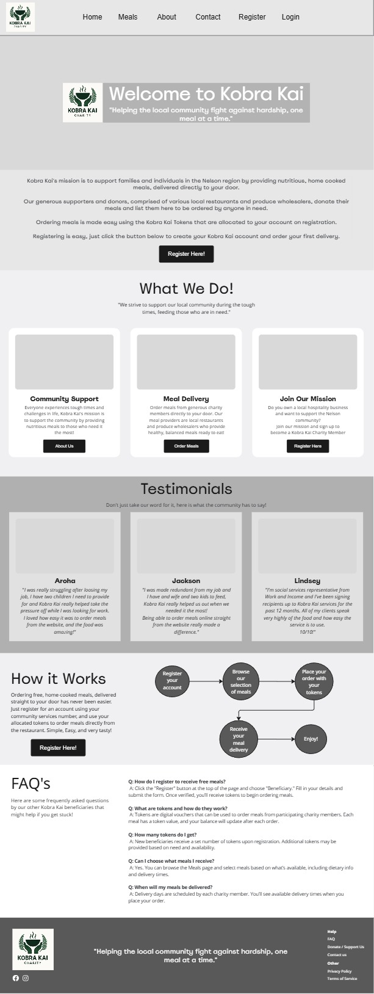

#### About Page

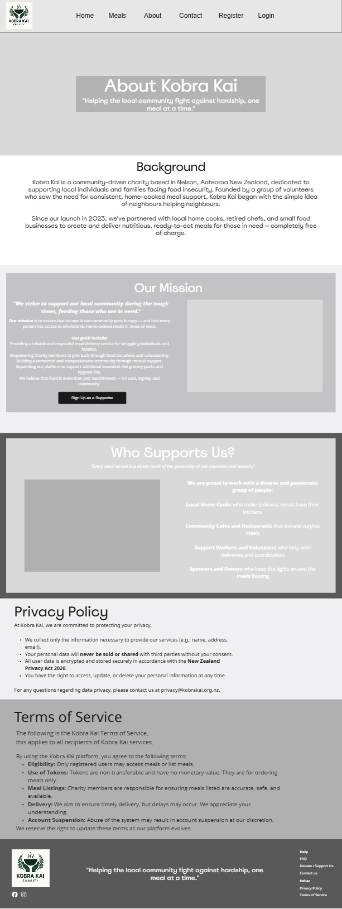

#### Meals Page

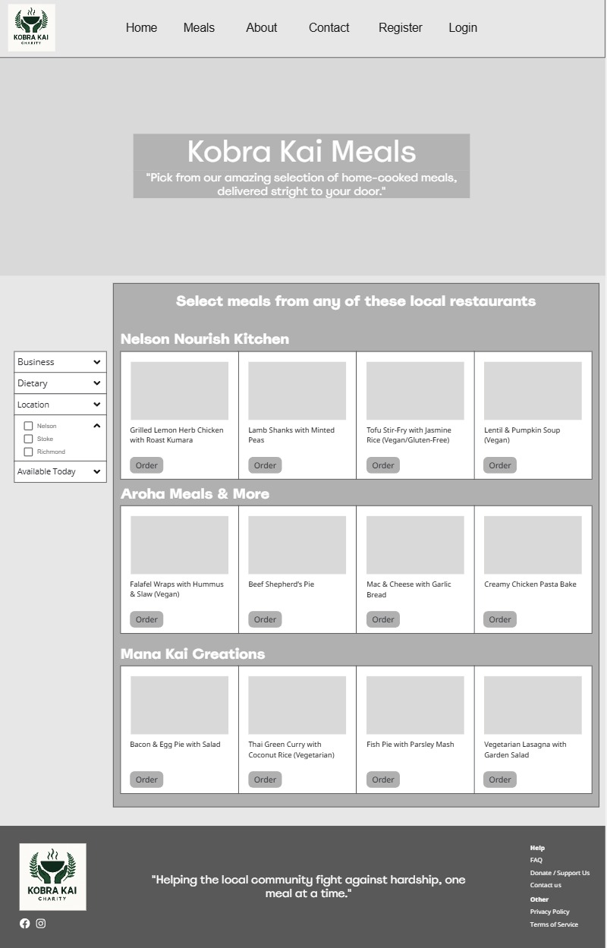

#### Contact Page

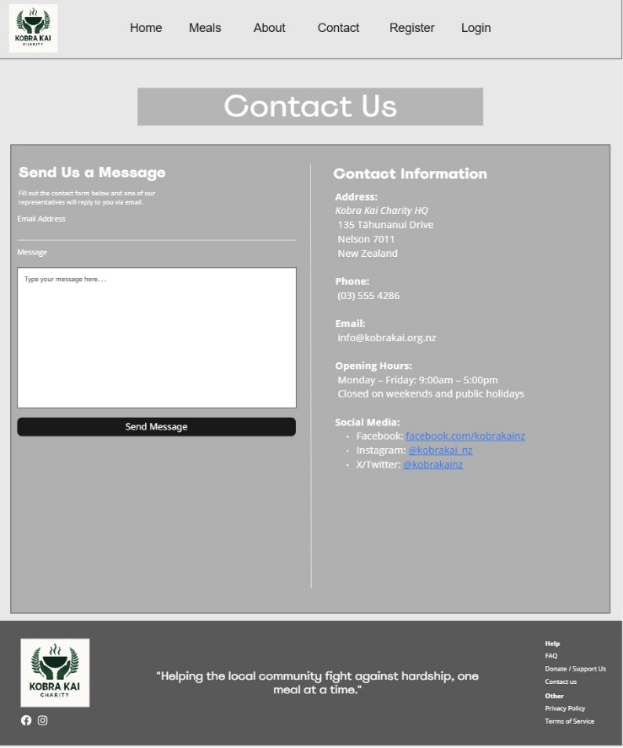

#### User Login Page

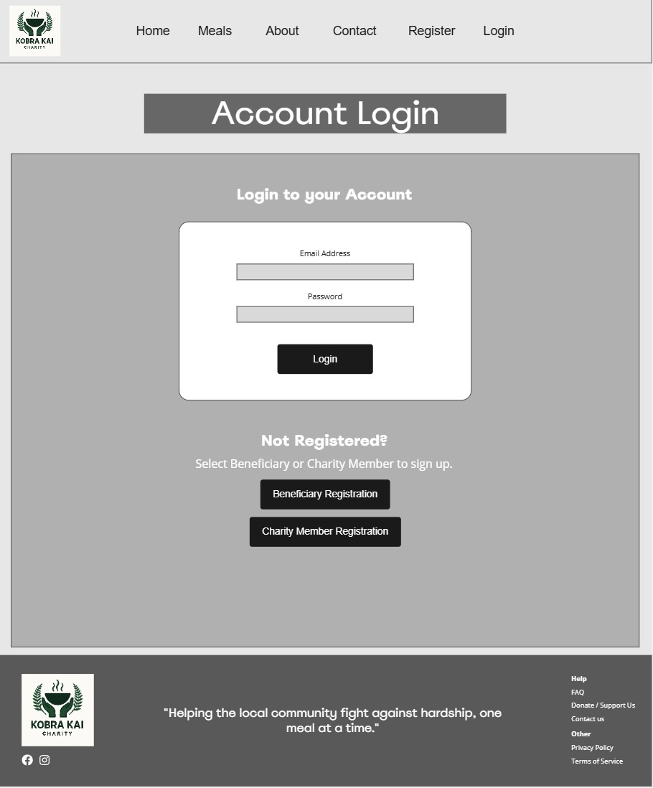

#### User Registration (Beneficiary View)

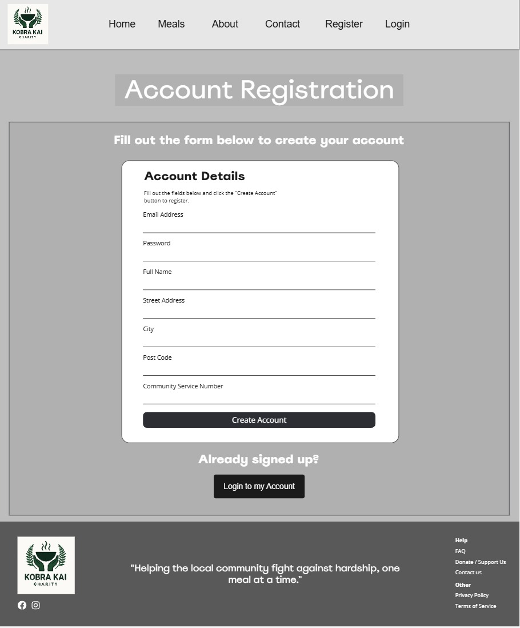

#### User Registration (Charity Member View)

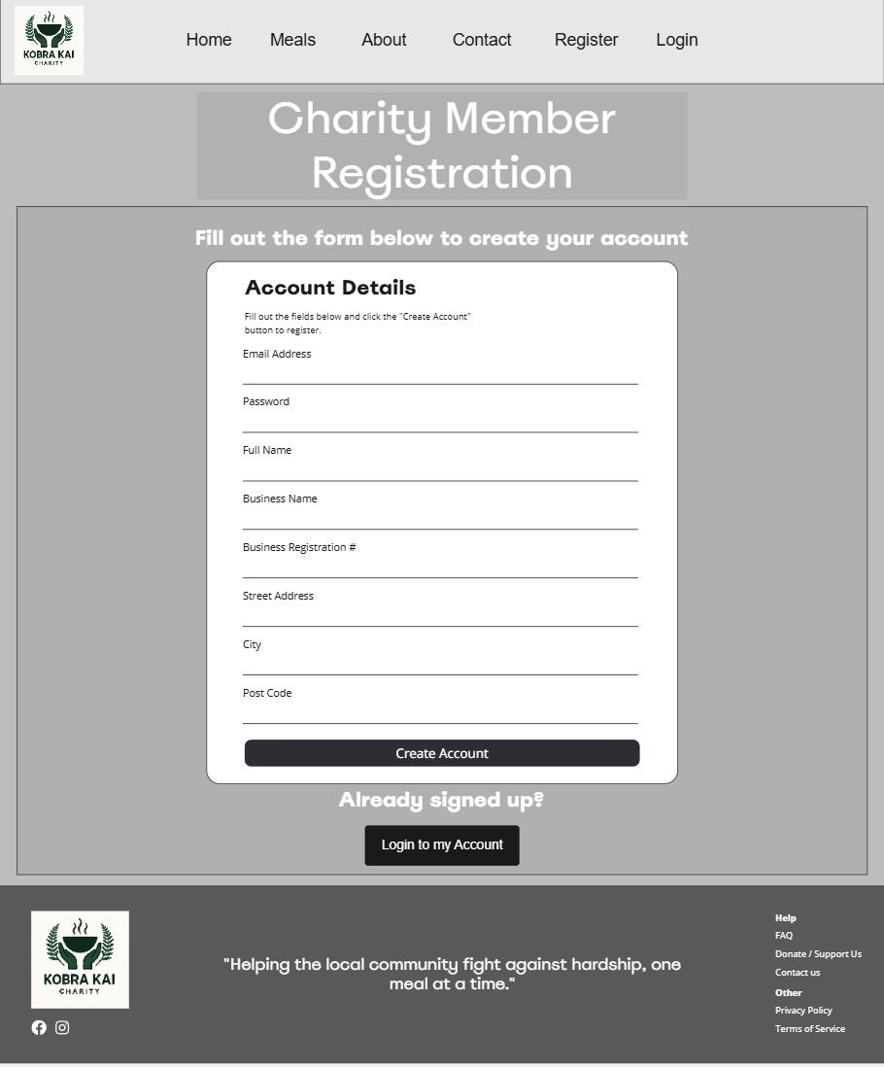

#### User Account Dashboard (Beneficiary View)

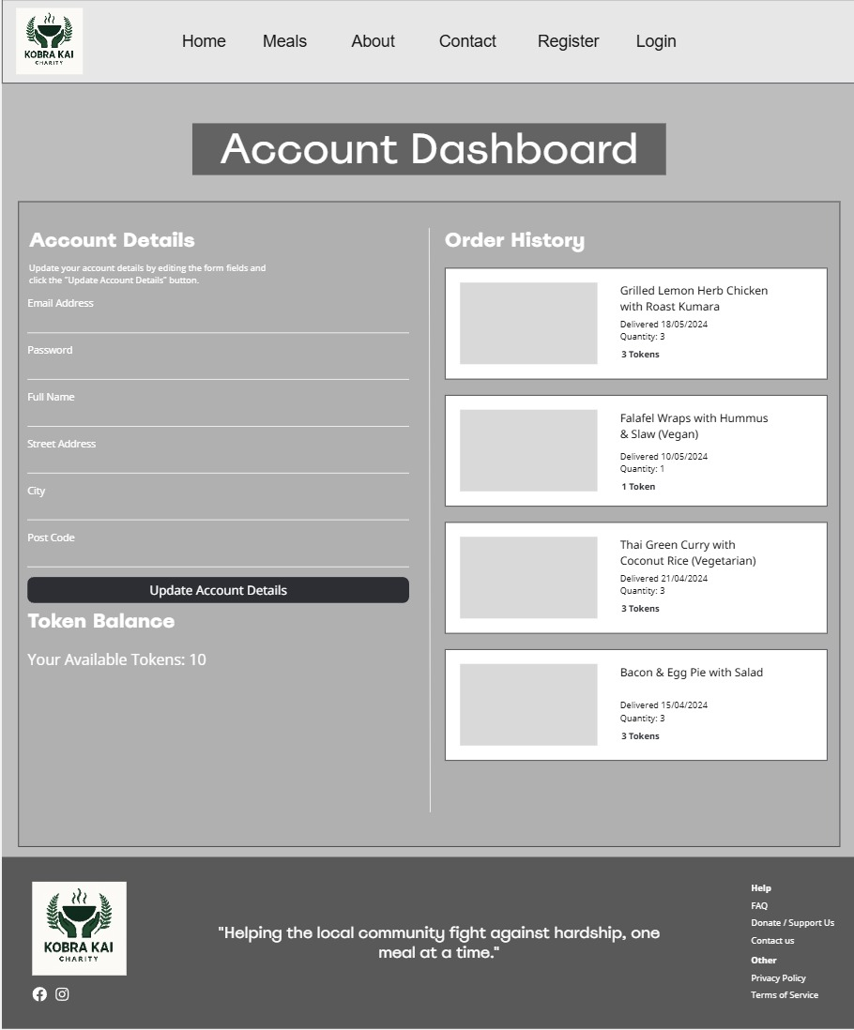

#### User Account Dashboard (Charity Member View)

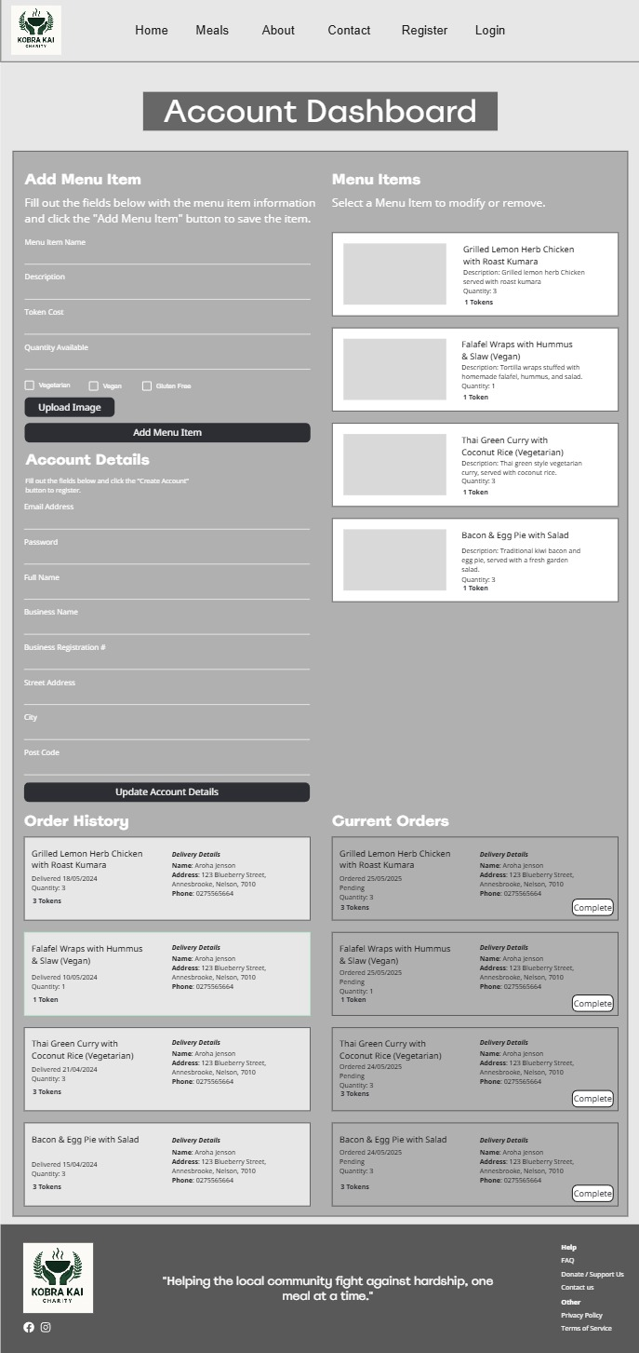

### High Fidelity Mock-ups

#### Home Page

#### About Page

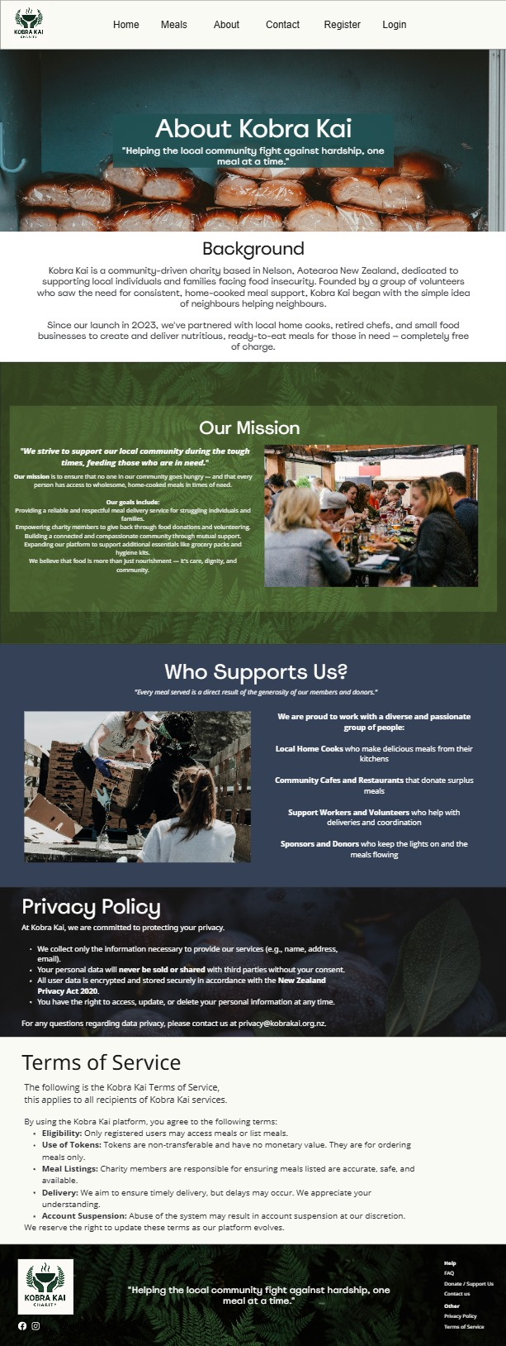

#### Meals Page

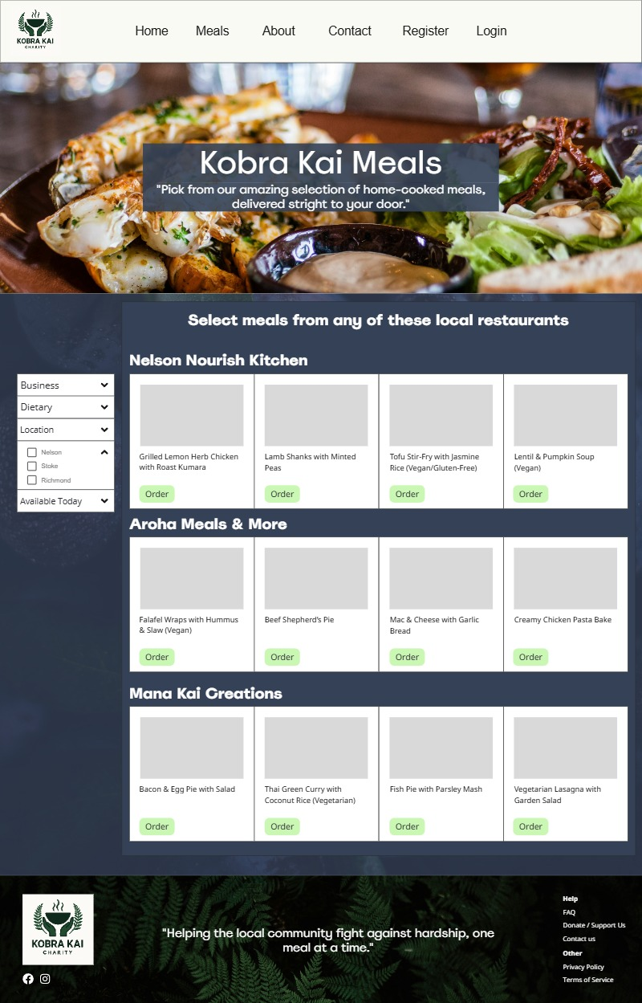

#### Contact Page

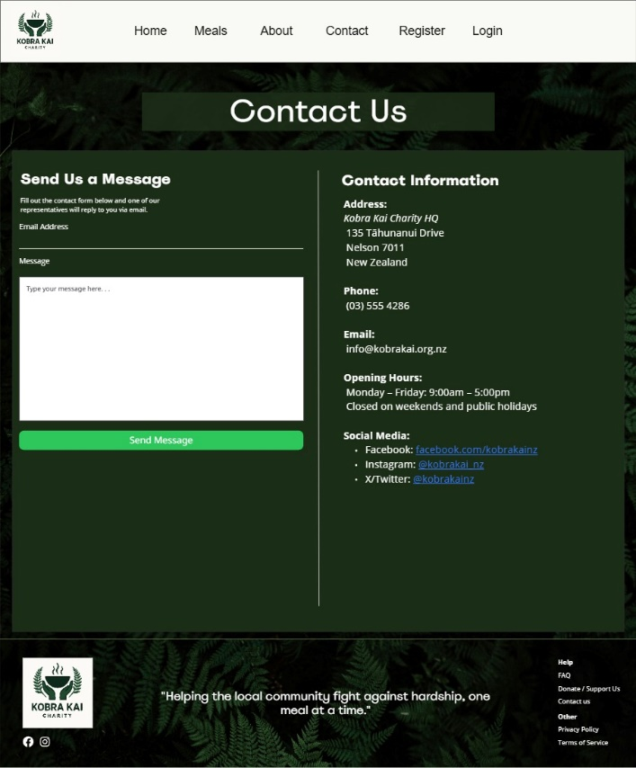

#### User Login Page

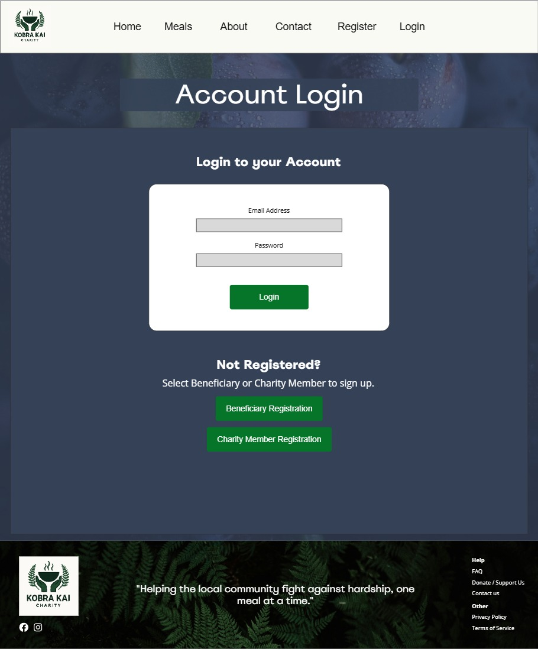

#### User Registration (Beneficiary View)

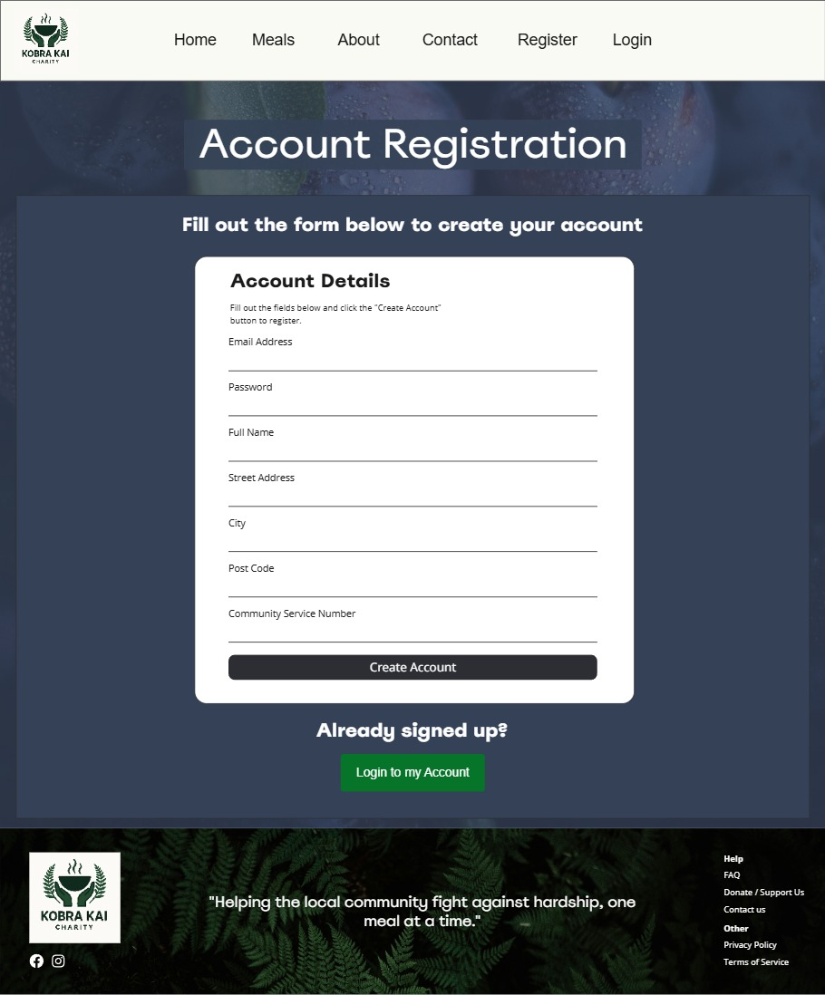

#### User Registration (Charity Member View)

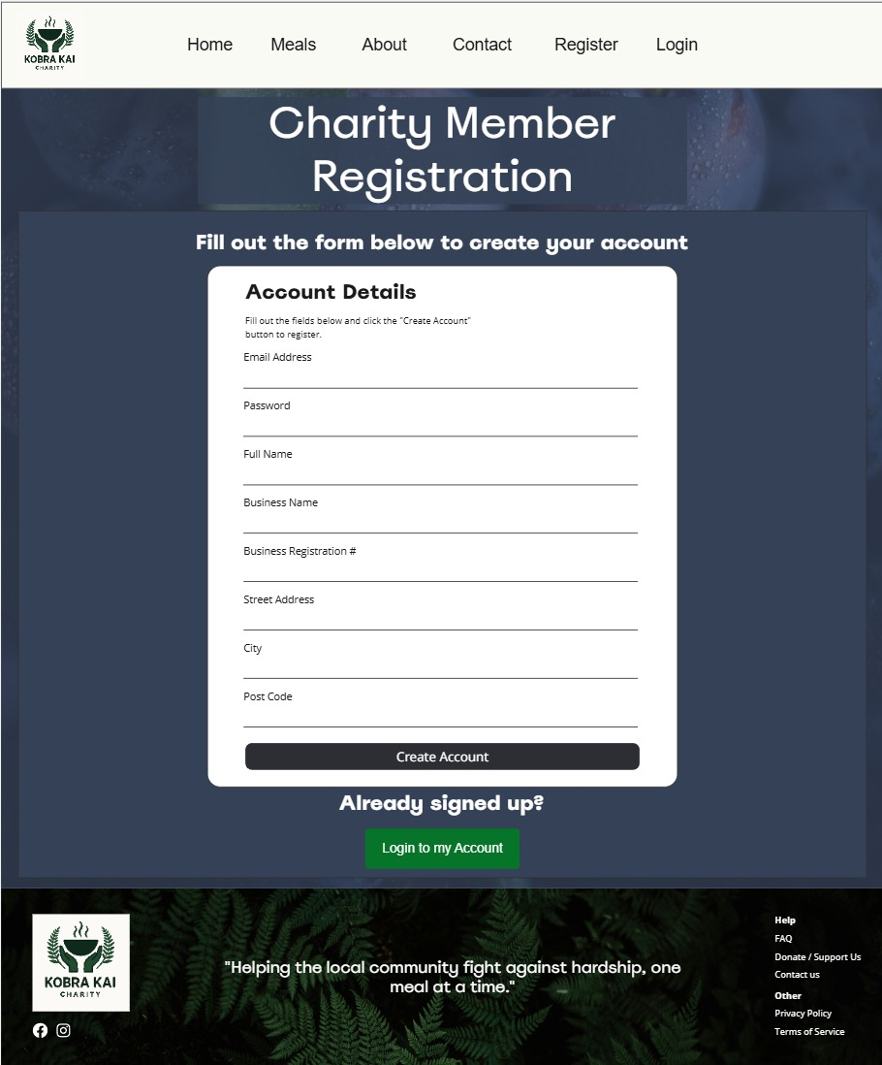

#### User Account Dashboard (Beneficiary View)

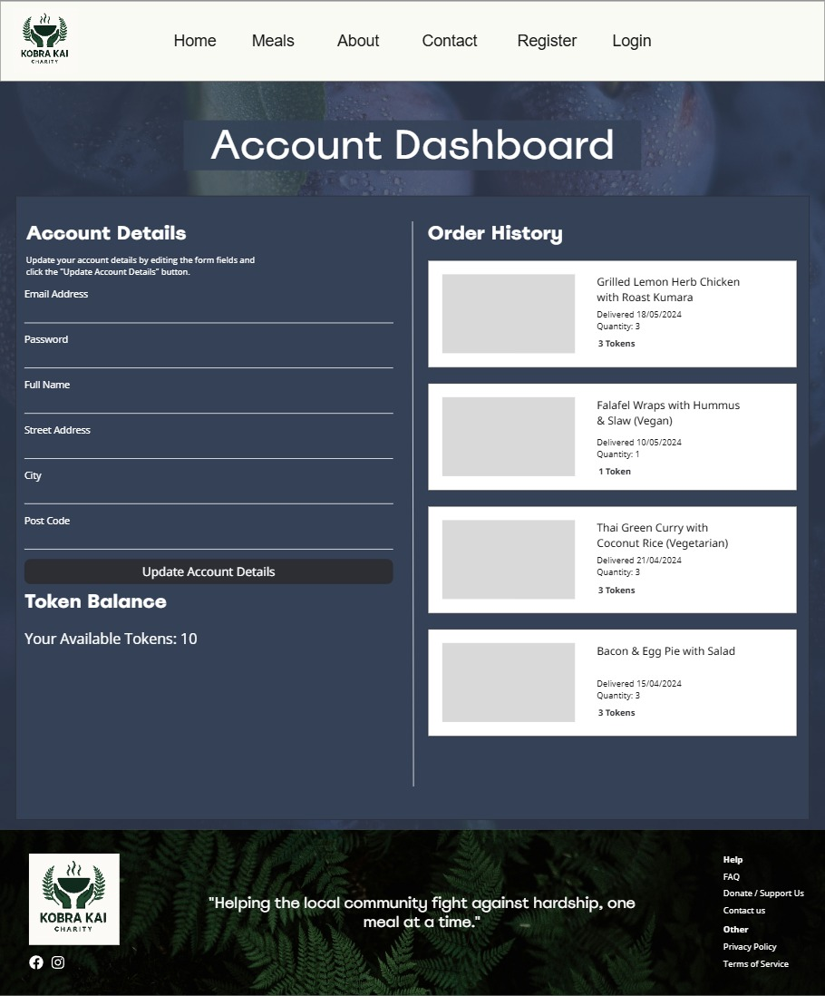

#### User Account Dashboard (Charity Member View)

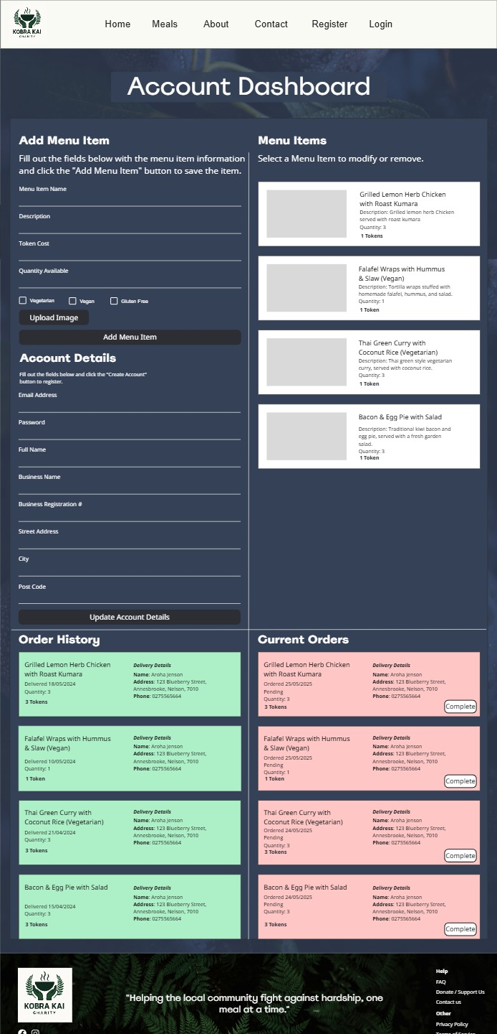

## CRUD Analysis and Table

This CRUD analysis section outlines the expected actions taken by the user and the relevant API method that needs to be performed. These methods are in the form of Create, Read, Update, and Delete (CRUD) and translate to API calls that are performed to invoke actions in the database or application logic. This is crucial prior to development as it informs the developers of the types of methods that need to be implemented into the API controllers as well as the routes and API endpoints that are expected to be used.

#### CRUD Table

|  |  |  |  |  |
| --- | --- | --- | --- | --- |
| **DB Entity / Table** | **User Story / Functionality** | **CRUD Operation** | **Description** | **Required**  **Fields/Columns** |
| **User (Beneficiary / Charity Member)** | Register for an account. | Create | Add a new user to the database. | Id, name, email, password, role, address, tokenBalance. |
|  | Login | Read | Authenticate User credentials. | Email, password, id |
|  | Update delivery address / account details | Update | Modify user details in database. | Address, name, email, phone. |
|  | View account dashboard | Read | Retrieve user profile information, meal listings, order history/pending orders, and token balance. | Id, name, email, password, role, address |
| **Meal** | Create a new meal listing (Charity Member) | Create | Add a new meal listing under the user’s account, to the database. | Id, title, description, dietaryTags[], portionsAvailable, deliveryDays[], provider |
|  | View All Meals | Read | Retrieve meal information to be displayed on the user interface. | Id, title, description, dietaryTags[], portionsAvailable, deliveryDays[], provider |
|  | Edit an existing meal listing (Charity Member) | Update | Modify the title, description, quantity, dietary, and image for a meal listing. | Id, title, description, dietaryTags[], portionsAvailable, deliveryDays[], provider |
|  | Delete or pause a meal listing (Chairty Member) | Delete / Update | Hard delete or soft disable a meal listing so it is not displayed on the user interface. | Id |
| **Order** | Place an order using tokens. | Create / Update | Create a new order entry and deduct token from user token balance. | Id, mealId, userId, status, orderedAt |
|  | View Order history | Read | Retrieve all orders for a user account. | userId, mealId, status, orderedAt, |
|  | Cancel an order | Delete / Update | Remove or mark order as cancelled. | Id |
|  | Mark order as completed (Charity Member) | Update | Change order status to “Delivered” with the delivery date. | Id, status |
|  | View pending/completed orders. (Charity Member) | Read | Query orders by status. | userId, status |
| **Token** | Allocate tokens on sign up (beneficiary) | Create / Update | Set initial token balance on user account. | userId, tokenBalance |
|  | View token balance | Read | Fetch token balance for user account. | userId, tokenBalance |
|  | Deduct Token on order submission | Update | Subtract token count on successful order. | userId, tokenBalance |
|  | Return token balance on cancelled order | Update | Add the token value that was returned to the user token balance. | userId, tokenBalance |
| **Contact** | Submit a contact of support message | Create | Save/send message to the database. | id, userId, name, email, message, sentAt |
|  | View messages (admin/future use) | Read | Fetch messages saved to the database. |  |
| **Auth Session (JWT)** | Login / Validate / Logout | Create / Read / Delete | Create session token, validate the user credentials, logout on client end. | userId, email, password |
| **Static Pages (Privacy / TOS)** | View site policies and FAQ’s | Read | Content is static, no DB changes needed. |  |

## API Endpoint Tests using Postman

The initial API controllers, routes, and models have been implemented for the core API functionality, as well as a MongoDB local instance was created to be used for testing the request and responses from the POSTMAN API tests. The following screen shots are the completed tests and the responses that were received.

#### Create Beneficiary User

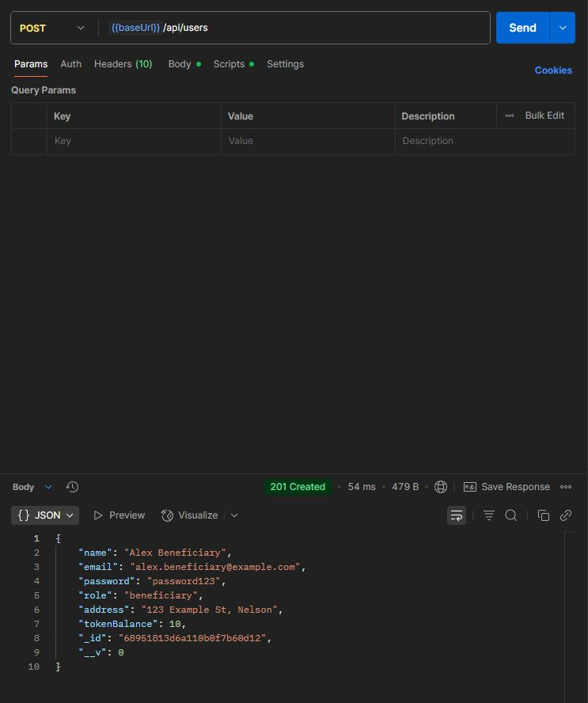

#### Create Charity Member User

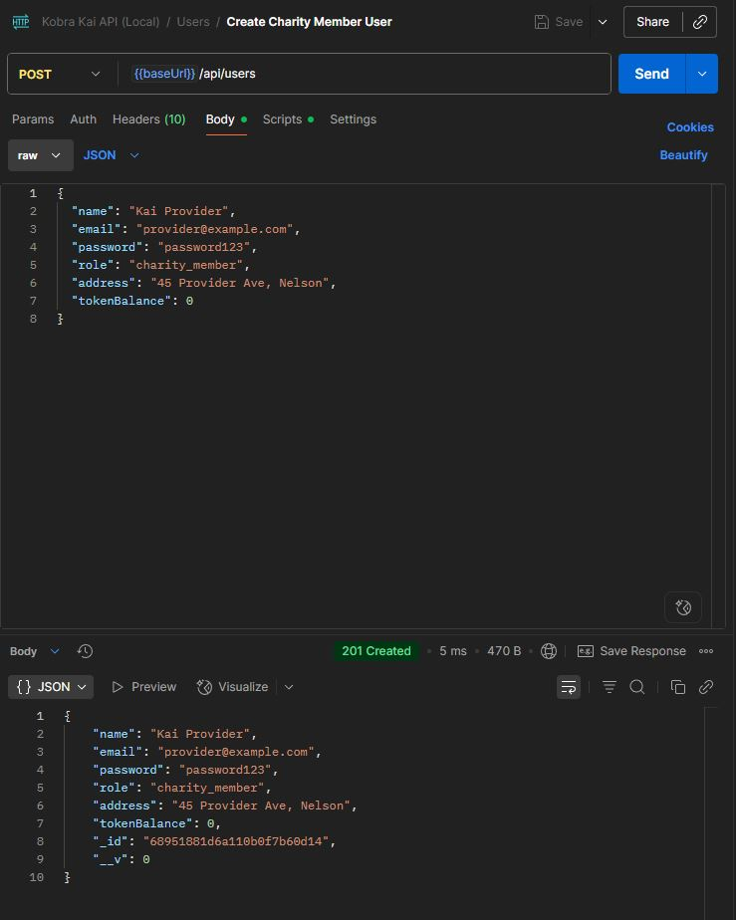

#### Get User By ID

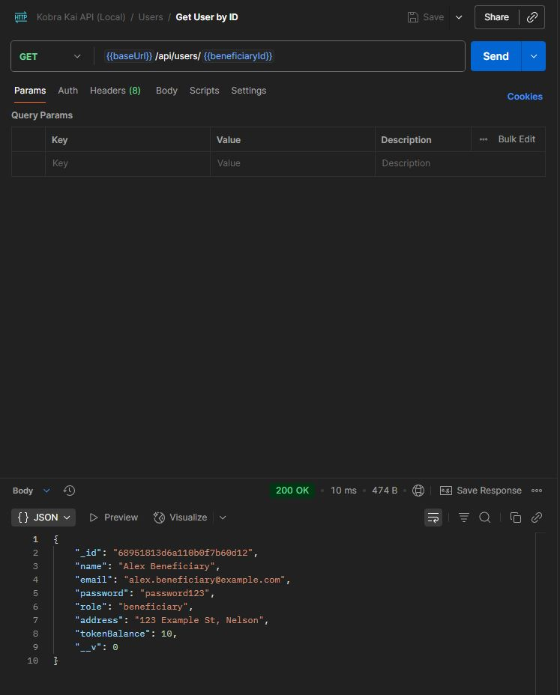

#### Update User Address

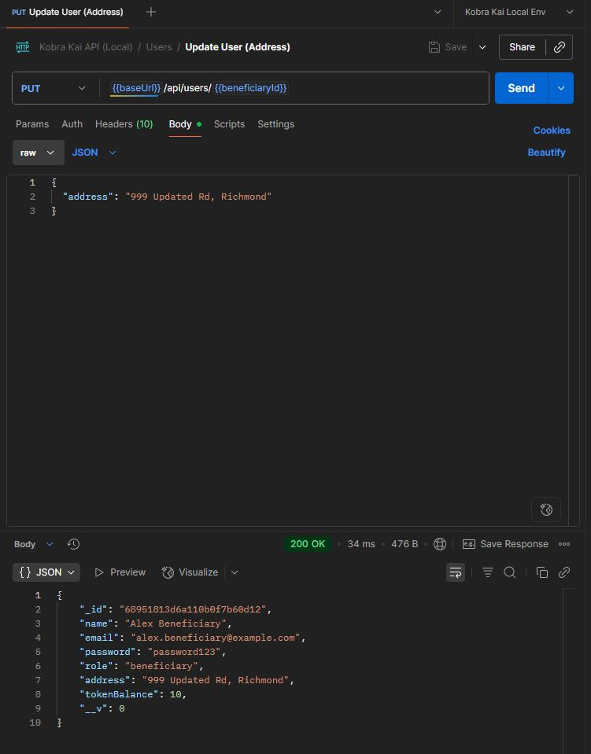

#### User Creation in MongoDB

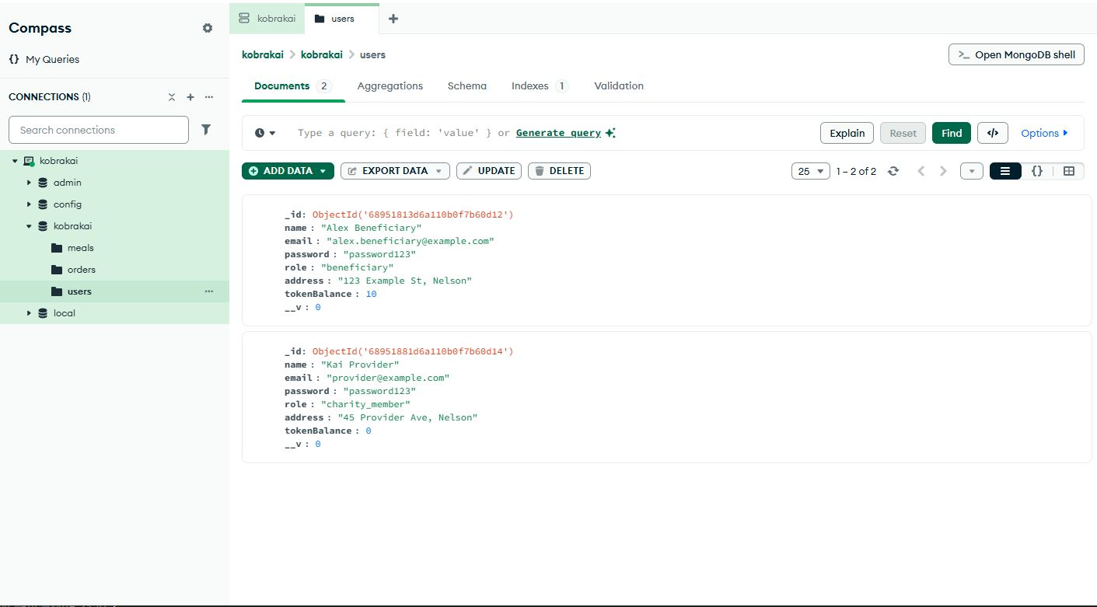

#### Create Meal

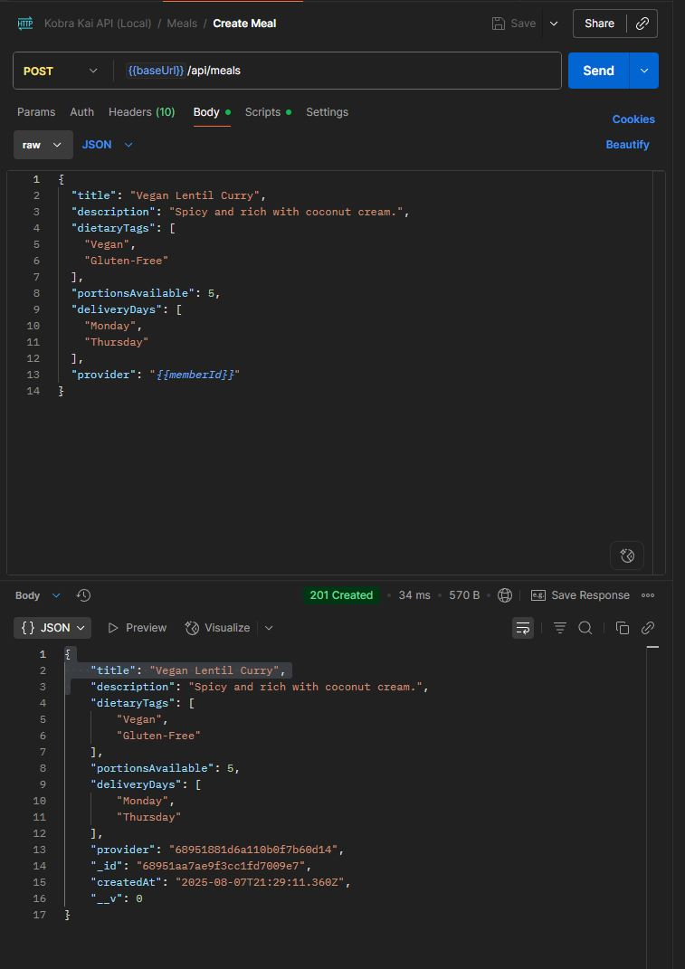

#### Get All Meals

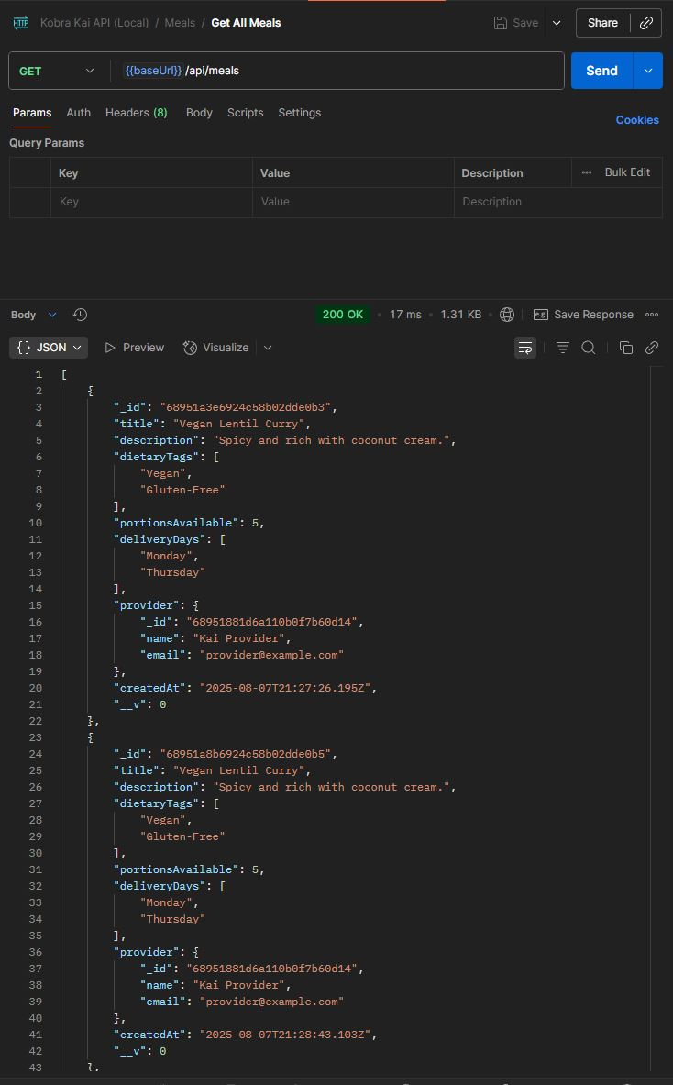

#### Get Meal By ID

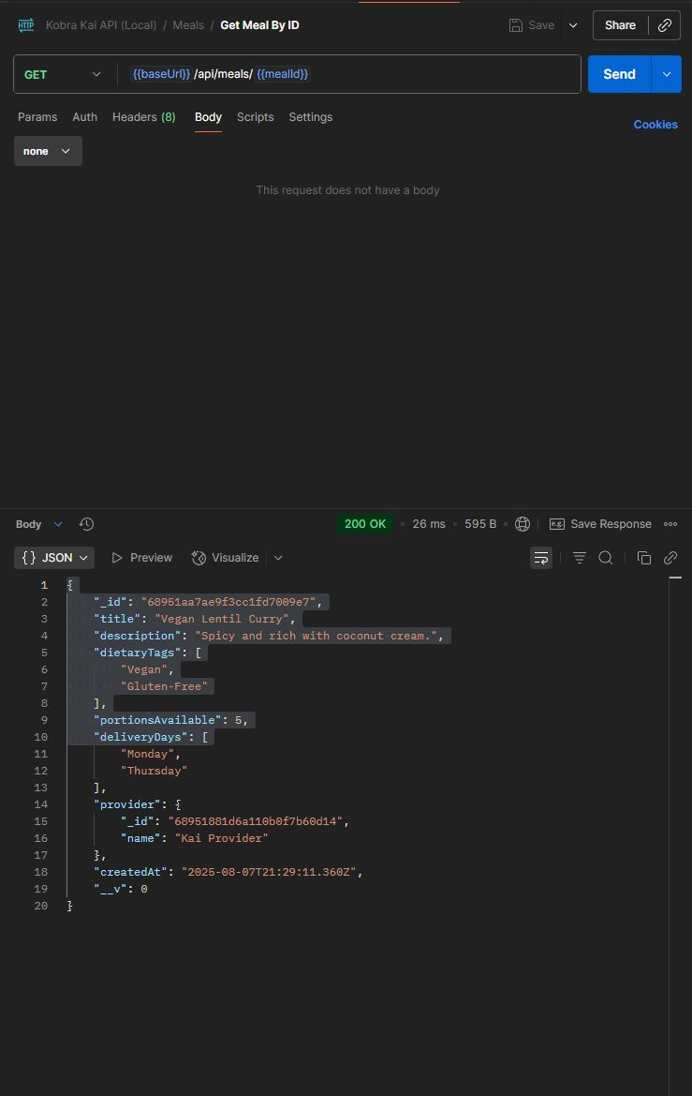

#### Update Meal Portions

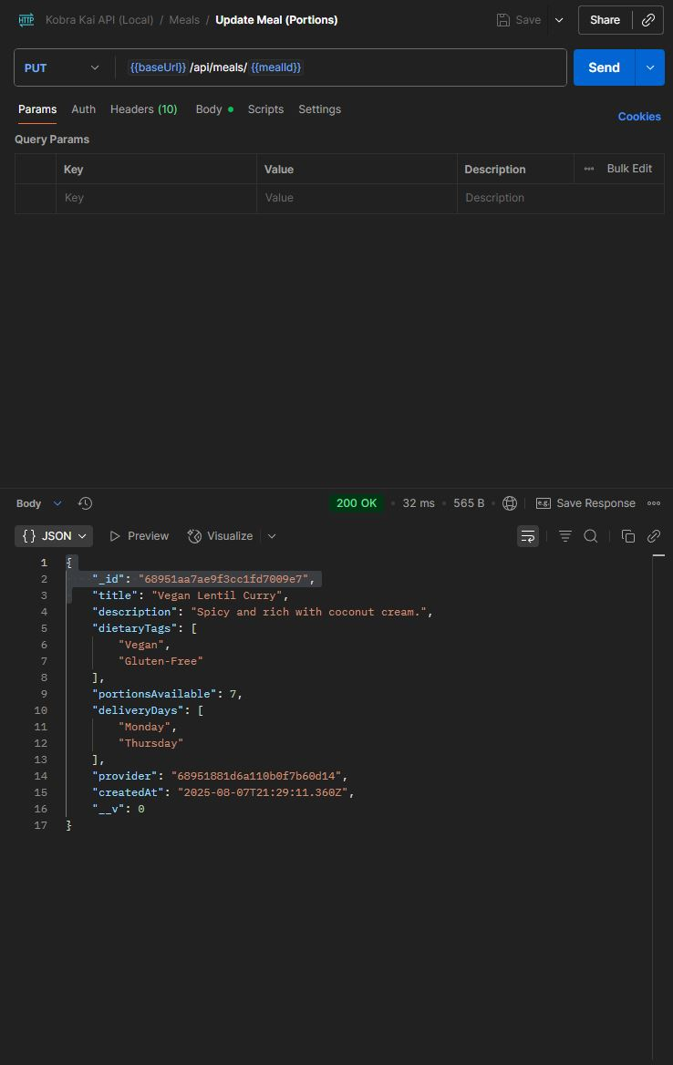

#### Place Order

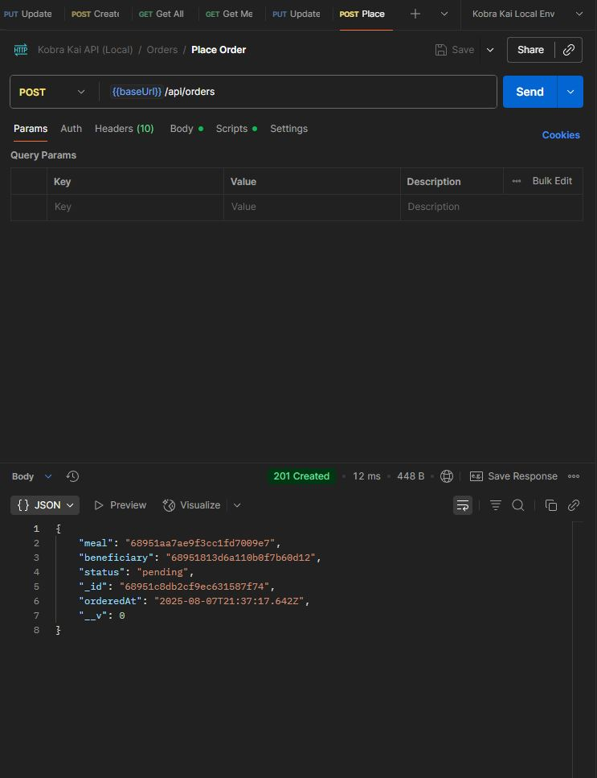

#### Get All Orders

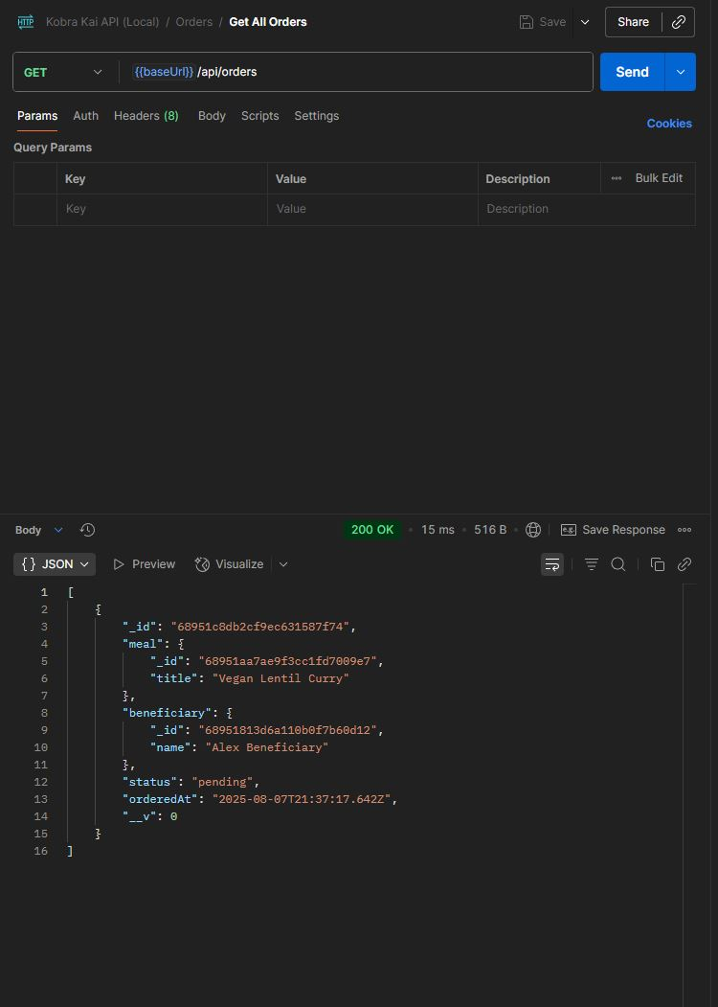

#### Update Order Status

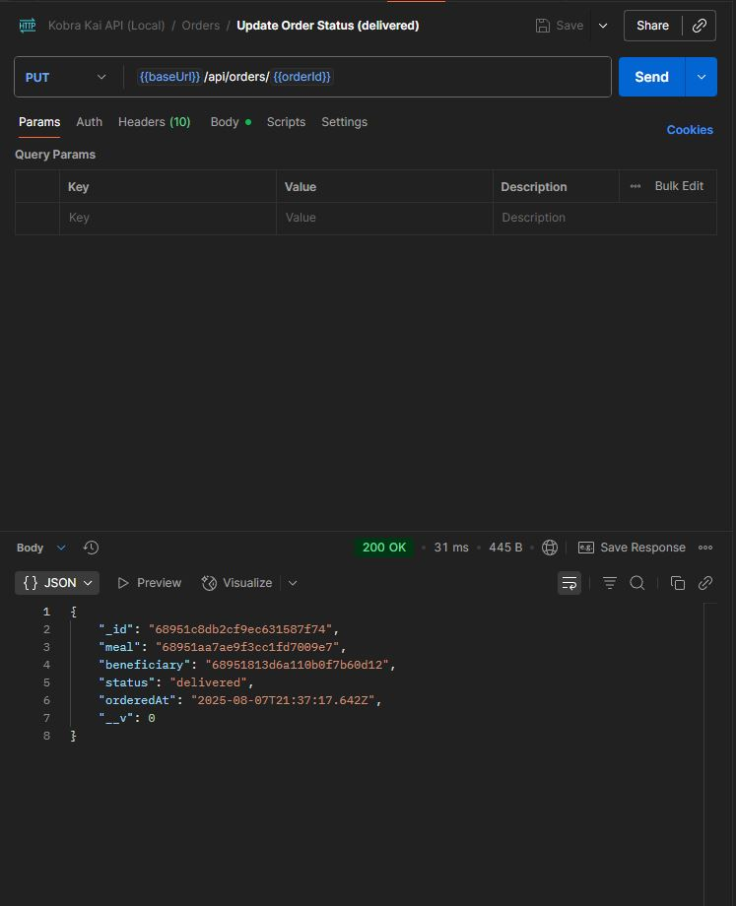

#### Mongo DB Tables after POSTMAN Tests

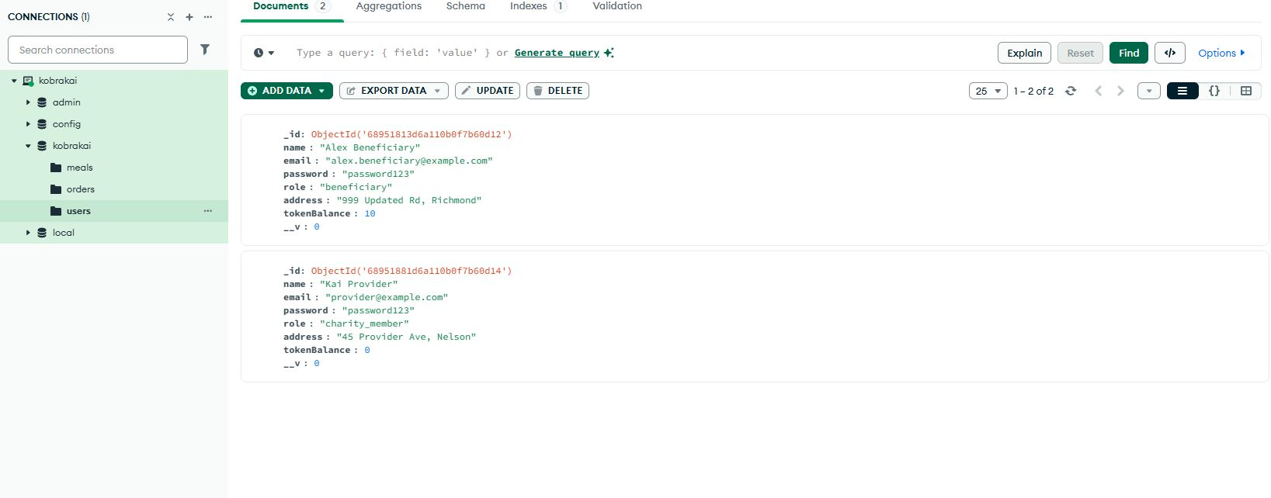

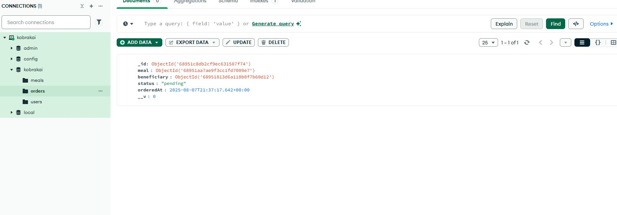

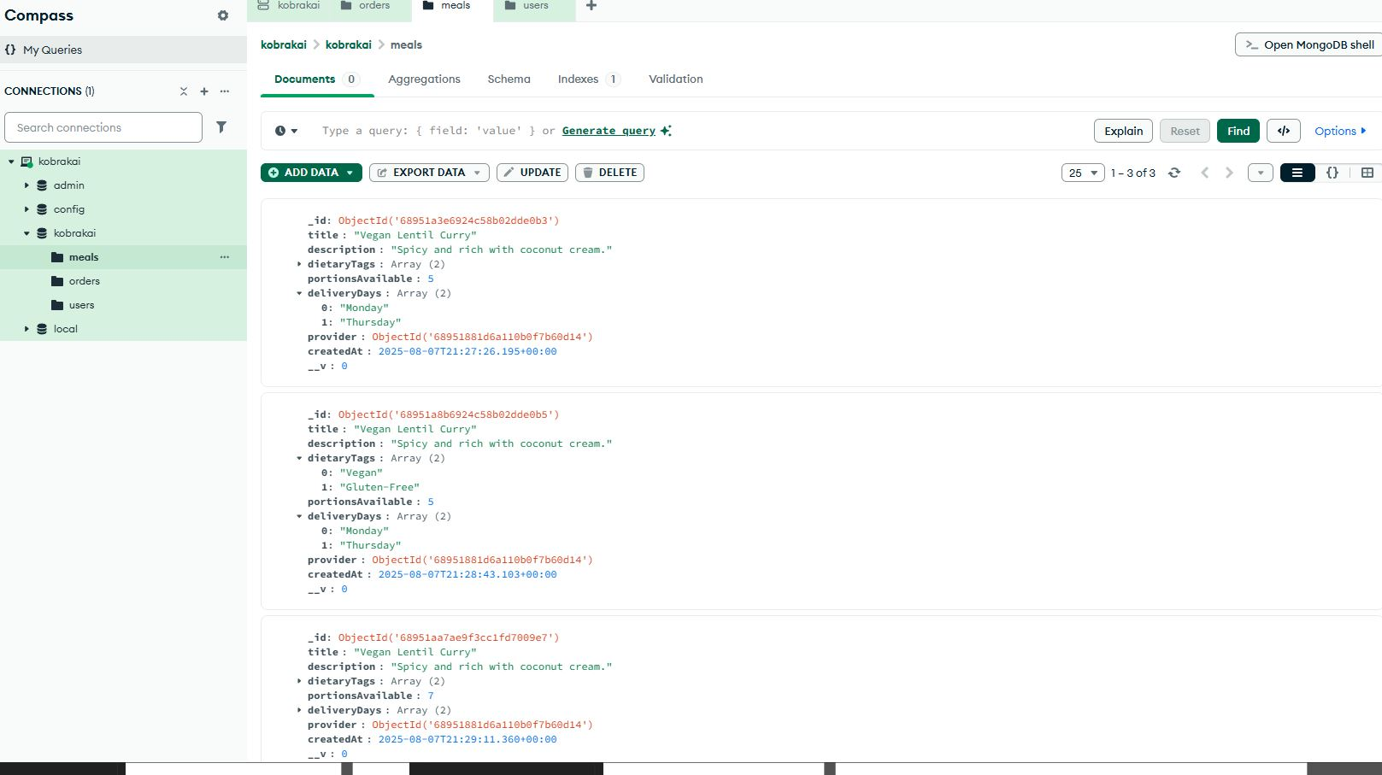

## Citations and References

Foodbank NZ. 2025. Foodbank NZ Website.

<https://www.foodbank.co.nz>

Bellyful. 2025. Bellyful Website.

<https://bellyful.org.nz>

Unsplash. 2025. Wireframe Images.

<https://unsplash.com>

MongoDB. 2025. MongoDB Community Server.

<https://www.mongodb.com/try/download/community>

Postman. 2025. Postman API Testing.

<https://www.postman.com>

ChatGPT. 2025. Kobra Kai Logo Creation Transcript.

<https://chatgpt.com/share/6895209f-6c7c-800d-8fd4-9c9ff1d99bf4>